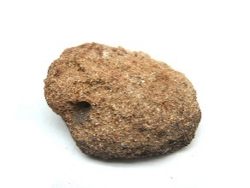

**What is soil made from?**

Rocks and Soils

SEDIMENTARY

These rocks form under the sea. Rocks are broken into small pieces by wind/water (**erosion**). They settle as mud, sand, minerals and even remains of living things. Over time, layers pile up and the pressure turns this **sedimen**t into rock.

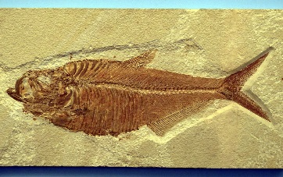

FOSSILS

**AIR** – Oxygen, carbon dioxide, nitrogen etc.

limestone

chalk

sandstone



**ORGANIC MATTER** – Living and dead plants and animals.

**lava**

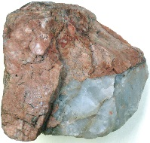

A fossil is the remains or the impression left by a prehistoric plant or animal embedded in rock.

It takes place in sedimentary rock because the heat from lava and magma in igneous and metamorphic rock would be too high for fossils to survive.

**WATER** – Air and water fill the gaps between particles of soil.

Igneous

Far underground, the temperature is so hot, rock melts into a liquid (molten rock).

When the liquid is underground it is called ‘**magma**’ and it can cool to form an intrusive rock. When it spills out (volcano), the liquid is called ‘**lava**’ and it cools to form extrusive rock.

. Heat proud

Drop, Water, Liquid, Purity, Clean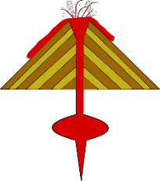

**MINERALS** – Minerals come from broken down rock.

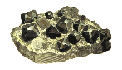

obsidian

granite

basalt

**magma**

**1.)** An animal, creature or plant dies and ends up at the bottom of the sea. It gets covered in a layer of rock.

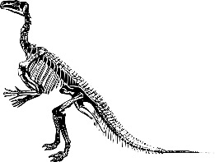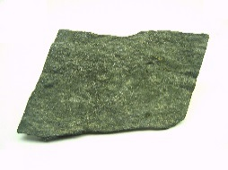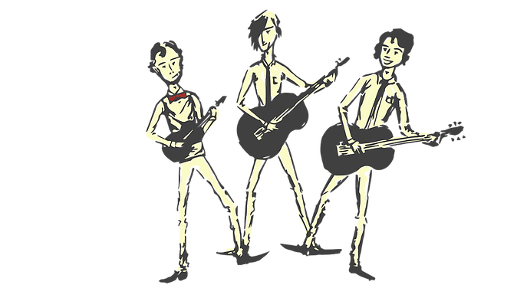

marble

quartzite

slate

MAN-MADE ROCKS (ANTHROPIC)

These rocks are made by humans.

***CONCRETE*** – a mixture of water, sand/rock/gravel and cement (chalk & clay)

***BRICKS*** – Clay soil, sand or lime which have been air-dried or fire-hardened.

***MOCK ROCK*** – Victorians made rock gardens and surfaces that looked like rock.

METAMORPHIC

When sedimentary or igneous rock is near magma, it **heats** up and chemicals change in the rock. However, it does not heat up enough to melt it. As it cools it becomes metamorphic rock.

**PROPERTIES OF ROCKS**

**1.)** HARD / SOFT – Some rocks need to be cut or split with tools because they are so hard (e.g. granite) but others are soft and can be moulded (e.g. clay).

**2.)** PERMEABLE / IMPERMEABLE – Permeable rocks allow water to pass through (e.g. pumice) but impermeable rocks do not let water pass through (e.g. marble)

**3.)** DURABLE – Rocks which are resistant to erosion last longer and are more durable. Buildings are often made with these (e.g. limestone)

**4.)** DENSITY – If the particles in the rock are tightly packed then it has a high density. These rocks would sink in water (e.g. basalt).

**2.)** Over time, more layers of rock form on top and the only thing which would remain are the bones or the space where the bones used to be (mould fossils).

**3.)** Sometimes sediment enters the space where the bones used to be and takes the shape of the creature (cast fossil).

**4.)** Over a long period, the sea may recede / go back leaving the rock.

**5.)** Erosion and weathering of the rock means the fossil can now be seen!



**FUN FACTS ABOUT MAGNETS**

* The most powerful magnet in the universe is a star called ‘Magnestar’.
* Animals can be affected by magnetic pulls. Birds and turtles navigate by them and sharks are repelled by them!
* Earth’s core is said to be filled with iron and nickel (metals which give it a magnetic field).

Earth has a natural magnetic field which means the pin turns to always face north and helping people find their way.