Dates for your diary
INSET dates for 2023-2024 are 04/09/23, 21/12/23, 03/01/24, 02/05/24 and 03/06/24. All other holiday dates are in line with Halton schools which can be found on our website.
Culture and wellbeing week
Week beginning 10th July we have a variety of activities planned. We have a storyteller, sports day, visitors and many other activities. Your class teacher will let you know the days when your children should wear PE kit.
Classes for September
We have some members of staff who will be leaving us in the summer. Miss Kinsella, Miss Fleming and Mr Myatt have all taken up new jobs elsewhere and we wish them well for the future. They have all been a fabulous asset to our school and we will miss them!
We have appointed some new members of staff, and are having a bit of a change around. Please see chart below.
Class | Teacher | TA
Rec | Miss Crofts | Mrs Murray
Y1 | Mrs Thomas | Mrs Edinborough  /Miss Johnson
Y2 | Mrs Cho | Mrs Farrow
Y3 | Mrs Hughes | Mrs Taylor
Y4 | Mrs Davison | Mr Davies
Y5 | Mr Gaskell | Mrs McDonnell
Y6 | Mrs Westbrook | To be confirmed

Mrs Williams and Miss Kelly will be covering classes when teachers have their PPA.
Your children will spend the afternoon with their new class teacher on Tuesday 4th July. Some children will spend more time meeting with their teachers and in their new classroom to help with transition.
Uniform
Reminder for September that the uniform list is available on the website. Our only supplier for school badged items is Kits 4 All.
School dinners and support
We have received notice from Halton that school dinners will be priced at £2.70 from September. (£13.50 per week). We encourage you to apply for pupil premium.
Below is the link to apply and this also provides extra funding for the school. https://cyp.halton.gov.uk/Synergy/Live/SynergyWeb/Parents/default.aspx
School times
As I confirmed previously all schools have to provide 32.5 hours in school from September. To accommodate this all classes will finish at 3.20 in September and the start time will be adapted slightly. From September the gates will open slightly earlier, classes will be let in at 8.40 and your child will receive a late mark if they are in the classroom later than 8.50am (previously 8.55) However, please try to be here for 8.40 so that your child can prepare for the day ahead.

Attendance and Illness
We follow the Emergency Contact and First-day Calling Procedures. If a child is going to be absent, parents or carers are required to contact the school office via telephone or email before 8.45 am. Absence contact details: (0151 257 2450 or sec.allsaintsupton@haltonlearning.net)
If no contact has been made by 8.55, Parents/ Carers will be contacted using their first contact on the list. If there is no response, the second, then third contact will be contacted.
If school staff are still unable to make contact then a welfare call will be made to the child’s home by staff. If staff are still unable to make contact at the child’s home then a card will be left and school staff will contact the police to carry out a welfare check.
Community
Please do not encourage or stroke the cat. It is now trying to enter school at every opportunity and has scratched a member of staff who tried to remove it. I have also received an email from a neighbour asking if we could not walk on the road at Danescroft. She is concerned that there will be an accident. Also please ensure you don’t walk on the grass at Dovedale Court as this belongs to the bungalows. I appreciate your support.
Online Safety
Please ensure that your children are not using the ‘chat’ facility on apps to talk to people that they do not know. We have heard of two incidents this week where the PCSO has been informed about concerns. Any incidents of this kind should be reported to: https://www.ceop.police.uk/Safety-Centre/ as this can help to ensure this does not happen to other children.
Healthy Schools
We were delighted that Grace and Oliver from Year 6 were able to collect our Halton Healthy Schools Award at the stadium last week.
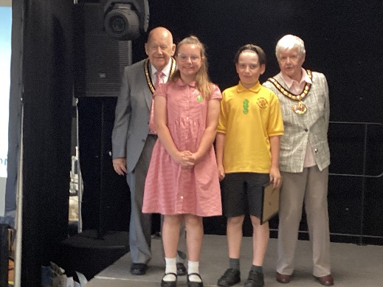
Infant Music Festival
Well done to all our Year 1 and 2 children who represented us at the Infant Music Festival this week.
Attendance for June
Reception | 88.84%
Year 1 | 92.61%
Year 2 | 91.20%
Year 3 | 90.36%
Year 4 | 91.54%
Year 5 | 91.87%
Year 6 | 94.82%
Well done to year 6 for the best attendance for June!
We have a busy July ahead of us, with lots of exciting learning planned so please ensure your child is in school during these last few weeks.
Mrs. Davies

