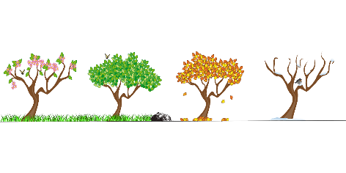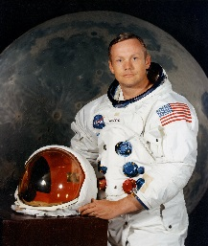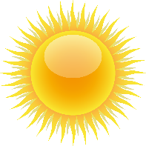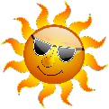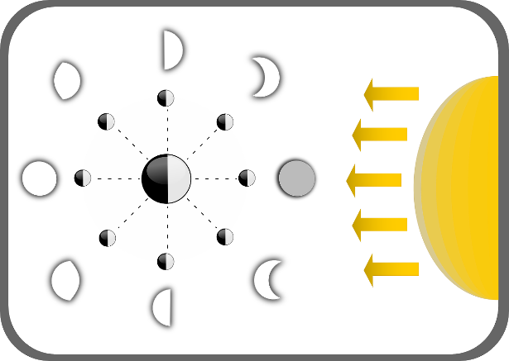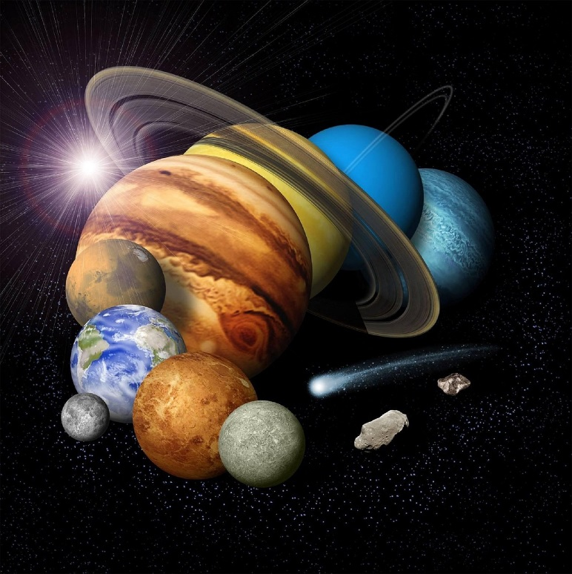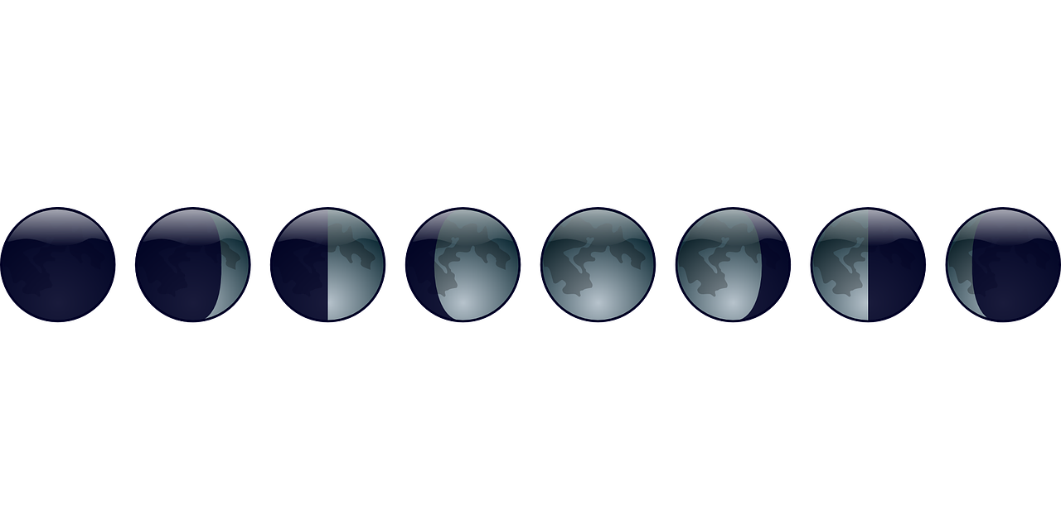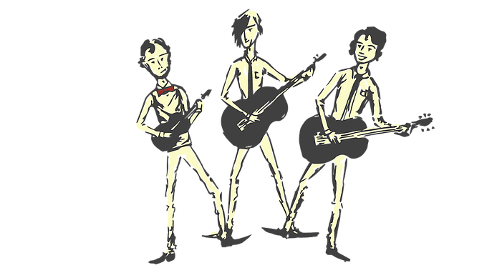

Waning means the moon looks like it is getting smaller. Waxing means the moon looks like it is getting larger. How much of the moon we see, depends on how much sunlight is hitting it. The moon reflects this sunlight.

**GEOCENTRIC** – People used to believe that the earth was the centre of the solar system and that the sun, and all the other planets, orbited it.

**HELIOCENTRIC** – Over hundreds of years, scientists began to understand that the sun was at the centre of the universe. They realised that all the planets actually orbited the sun not the earth.

**The Sun**

A star at the centre of our solar system.

15 million degrees hot at its centre. It is 1.3 million times bigger than earth.

The Sun is incredibly bright. It is not safe to look directly at the sun, even when wearing sunglasses!

Neil Armstrong

(The first man to step on the moon - 1969)

A solar eclipse is when the moon passes between the sun and the earth so the moon blocks the sunlight.

The Solar Eclipse

Time

The Earth to spin once on its axis.

(When the Earth faces the sun it is daylight and when it faces away from the sun it is night. It makes the sun appear to travel across the sky)

24hours

The moon to orbit the Earth

(A lunar month – see Phases of the Moon)

28 days

The Earth to orbit the sun

(Every 4 years there is a leap year due to the extra quarter – an extra day in February)

365 days ¼ days

The Earth’s tilt on its axis is what causes the 4 seasons. Sometimes it points towards the sun and other times it points away from the sun.

Mercury, Venus, Earth, Mars, Jupiter, Saturn, Uranus, Neptune

(Pluto was reclassified as a dwarf planet in 2006)

Waning

Crescent

Last

Quarter

Waning Gibbous

Full Moon

Waxing Gibbous

First

Quarter

Waxing Crescent

New Moon

Phases of the Moon

Earth and Space