A great start to 2023!
It has been a busy but very chilly start to the New Year. Hopefully the days are getting a bit lighter now and the weather a bit warmer. We are pleased that we have managed to have the entrance gate changed to ease the congestion at the start and end of school.
Some of our Year 5 and 6 children took part in a swimming gala and did us proud. We may not have won any medals, but their sportsmanship and support for each other were worth far more than that.
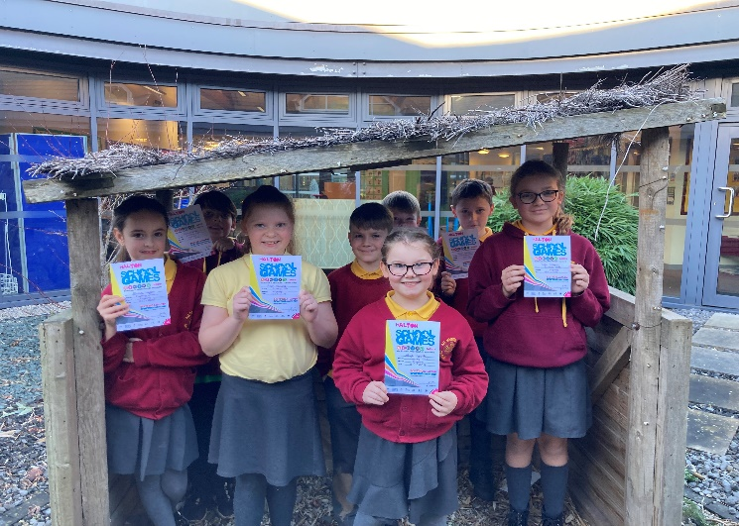

Dates for your diary
Year 6 will be doing assessments next week in preparation for their SATs.
SATs meeting for the parents of Year 2 children on Tuesday 7th February at 2.30pm
Uniform give away and book sale
Following on the success of this in the summer we will once again be holding a free uniform give away on Tuesday 14th February. If you have any good quality uniform (no stains, rips etc.) which no longer fits your
child then please donate it to school by this date. Check those summer dresses! We are particularly happy to receive any older age clothes as we have a shortage of these in school in case of emergencies. We will be opening the hall at the end of the school day for you to come in and help yourselves to any uniform that your child could use. Bring a bag and help the environment and your pocket. We will also be holding a book sale on this day. We have had a big clear out of our reading books, and are happy for you to take any of these home for the bargain price of 20p a book.
School will close for half term on Thursday 16th February at normal time.
Advance notice- Parents Evening will be on Tuesday 28th March and Wednesday 29th March. More details to follow.
Inset days for next academic year.
I have had parents asking about our holidays for 2023-24. Halton have a calendar up on their website (just google Halton school holidays) but we will have 5 Inset days on top of this for staff training when children will not be in school. The proposed dates for these are 4/9/23, 21/12/23, 03/01/24, 9/5/24 (this is pending local election dates) and 3/6/24. If you are planning holidays please bear these dates in mind as holidays in school time cannot be authorised.
Reminders:
Scooters and bikes must not be used within the school gates. If children continue to do this then we reserve the right to ban your child from bringing these to school.
Vaping and smoking are not allowed on school premises including any outside areas
Any water bottles that children bring to school must have sports caps, not just lids that unscrew to avoid spillages.
Help and support
Any Year 4 children who are Catholic are invited to a parents meeting about first Holy Communion. These are 1/2/23 at St Michaels and 2/02/23 at St Basils, both at 2.30pm
Margaret Gorst, our school nurse will be running a drop in clinic at school on the last Wednesday of every month for help with sleep, fussy eating, anxiety etc. As we are on half term in February her next date will be Wed 29th March.
PTA
Please get in touch if you would like to become involved in the school Parent Association. In the past we have been very grateful for the events that this group run for us, but they are down in numbers and would love to have a re-boot! They are open to suggestions about when and where to meet, and any ideas that you have for fund raising.
Clubs
We were delighted with the feedback we received from our parent questionnaire. However, one issue which did come up was clubs. Many of you asked if some clubs could be held at the end of the day. Unfortunately these clubs are run by external agencies and often paid for by school. These agencies can only offer us particular times. Our after school clubs are usually run by school staff and there are only so many clubs that we can offer. We hope that any issues with cancellations of clubs have been ironed out, as we appreciate that this can affect parents.
Attendance and punctuality
Our whole school attendance: 92.6%
Reception | 91%
Year 1 | 93.4%
Year 2 | 92.9%
Year 3 | 94.3%
Year 4 | 93.5%
Year 5 | 90.9%
Year 6 | 92.8%
Attendance was down in all classes this month, which is disappointing. From next month we will be looking to introduce further rewards for good attendance.
Finally, a goodbye…
Mrs. O Neill will be leaving us at half term to take up a new position as a positive behaviour support practitioner for the National Autistic Society. While we are delighted for her, and so proud of what she has achieved we are going to miss her terribly. In the time that she has worked at All Saints Upton Mrs. O Neill has supported many children, both in class and through support groups. She is a truly valued member of staff but will be a fabulous asset in her new role. Please be assured that we are currently undertaking a recruitment process for her successor.
Mrs. Davies

