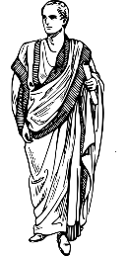
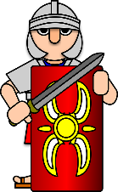
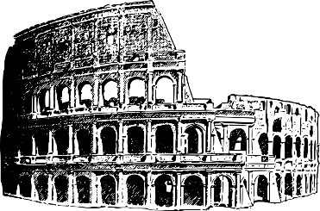
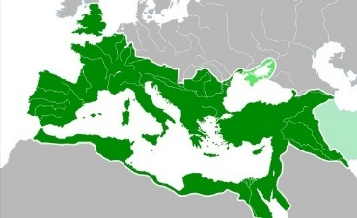
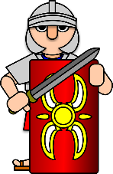
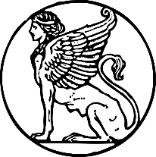
Britain
Roman
Empire
Roman Britain
Timeline
753 B.C. | 264-146 B.C. | 58-51 B.C. | 54 B.C. | 43 | 61 | 122 | 200 | 480-550
Rome was founded | Three Punic Wars between the Romans and Carthaginians | The Gallic Wars take place | Julius Caesar attempts to invade Britain | Invasion ordered by Claudius is successful | Iceni revolt led by Boudicca in Britain | Hadrian’s Wall built to separate Scotland and England | Christianity introduced | Arrival of the Anglo-Saxons in Britain
 | Key Vocabulary
aqueduct | Long stone waterways that delivered fresh water to cities, flowing into a holding tank (castellum).
Basilica | A type of church given special privileges by the pope. Also used for public meetings and a law court.
baths | Using a central heating system, the Romans would create public bathing areas using terracotta bricks.
Colchester | Was the Roman capital of Britain until it was destroyed under Boudica’s rebellion.
Colosseum | A huge oval amphitheatre built in Rome holding approx. 60,000 people to watch gladiators battle.
Empire | Controlled from Rome, the Empire included most of Europe, the Mediterranean and North Africa.
Hadrian’s Wall | A defensive wall separating Scotland and England with forts every 5 miles, stretching for 80 miles.
gladiator | An armed combatant who entertained audiences in violent battles with gladiators, criminals and animals.
roads | The Romans built the first roads in Britain (over 9000km of them) and were distinctively straight.
toga | Romans often wore large, white woollen pieces of fabric carefully draped over the body.

Roman Towns
There were all laid out in the same way with straight streets shaped in a grid pattern, with buildings like a bath house, temple, aqueducts and an amphitheatre. They also had forums, which were big open squares where people could set up stalls to sell things.

The Iceni
In 60, a rebellion started in the SE of England, led by Queen Boudicca, widow of Prasutagus, king of the Iceni. The Iceni, who felt betrayed by the new emperor, Nero, attacked Colchester, London and then St Albans, leaving between approx. 80,000 people dead. Paulinus led his army back to England and met Boudicca’s Iceni forces at the Battle of Watling Street. Despite being massively outnumbered, the superior battle skills of the Roman army won and the Iceni forces were defeated allowing the Romans to take firm control of the southern areas of England.

What Happened to the Romans?
The Empire became too big to rule and In 285, Emperor Diocletian split the Empire in two halves, East and West. The Western Empire ended in 476, and the Eastern Empire carried on until 1453. Britain was part of the Western Empire, but the Romans left it in 410 AD because the soldiers and leaders who ruled Britain were needed to defend other parts of the Empire.
General Knowledge

Julius Caesar (100 B.C. – 44 B.C.)
His defining moment was when he crossed the Rubicon, a river that bordered Rome, and led an army into Rome to take over the government. He won many battles but was only emperor for a year until he was killed by his political enemies on the Ides of March (15th March). He invaded Britain twice but did not set up any forts.

Caesar Augustus (63 B.C. - 14)
Seen as the first real Roman Emperor when he took power in 27 BC, he was Julius Caesar’s adopted son. That’s why 27 BC is seen as the true date of the start of the Roman Empire.

Claudius (10 B.C. – 54)
Led to the successful invasion of Britain and was responsible for building lots of new roads and aqueducts throughout the Empire.

Constantine (272-337)
The first Christian Emperor who tried to unite a split Empire

Famous Figures
Coins were used to trade but were also ways for the emperor to tell people about the great things they did (or wanted people to think they did). Coins could be minted that showed pictures of them with their name or other words and symbols on it.

