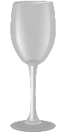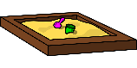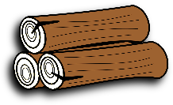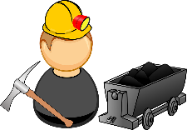**EEPING COOL**

Solids, liquids and gases are called the three states of matter. Materials can be changed from one state to another by heating or cooling.

## Heating

* If ice (solid) is heated, it changes to water (liquid). This change is called **melting**.
* Water (liquid) can change to water vapour (gas). This is called **evaporation**.
* If water (liquid) is heated until it **boils**, it changes to water vapour (gas) very quickly. Water boils at 100°C.

## Cooling

* If water vapour (gas) is cooled, it changes to water (liquid). This change is called **condensing**.
* If water (liquid) is cooled, it changes to ice (solid). This change is called **freezing**. Water freezes at 0°C.

**CHANGING STATE**

MAN-MADE

NATURAL

. Heat proud

States of Matter

Gold Bar, Bullion, Gold Bullion, Gold Ingot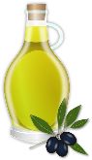

**Three states of matter**

**GAS**: particles far apart and randomly arranged / move around

**LIQUID**: particles close but randomly arranged / move around

**SOLID**: particles very close together / vibrate around a fixed position



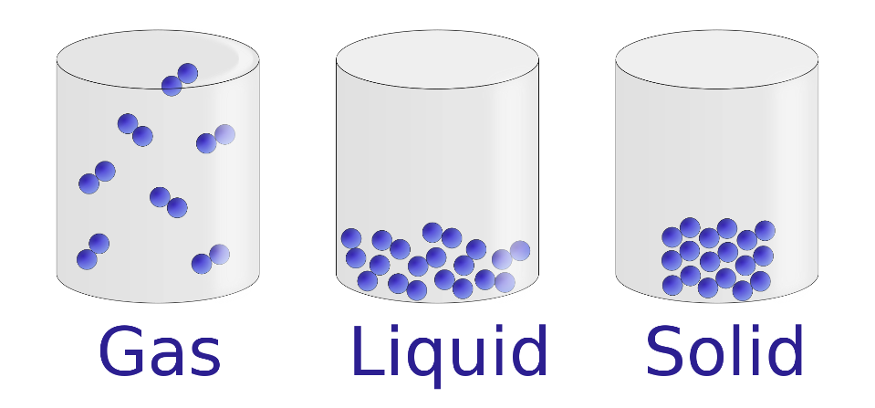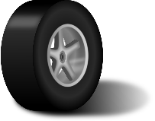



FREEZING

CONDENSATION

**Examples**

Ice

Wood

Glass

Diamond

MELTING

EVAPORATION

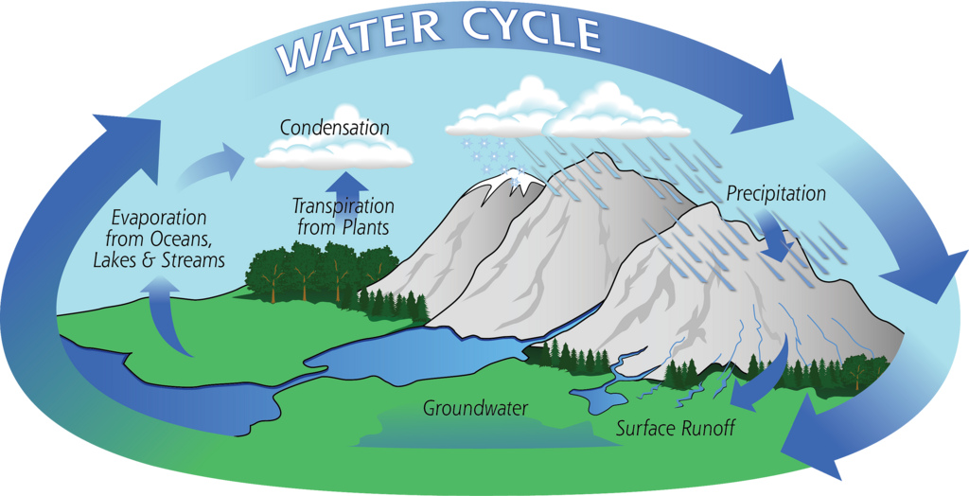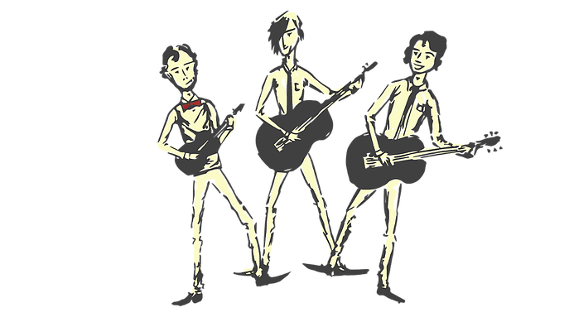

**FEATURES**

* Solids hold their shape. (Salt, sand and sugar are tiny solids so they pour like a liquid but they pile up and are nit wet.)
* Liquids form a pool not a pile!
* Gases escape from an unsealed container and fill the entire volume of space.

**Examples**

Water

Milk

Washing up liquid

**Examples**

Steam (water vapour)

Hydrogen

Carbon Dioxide

Oxygen

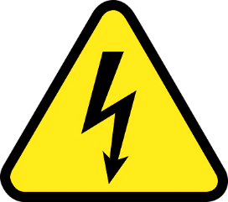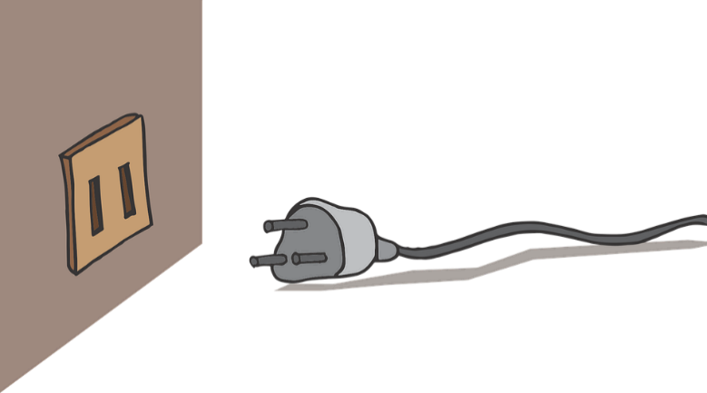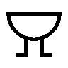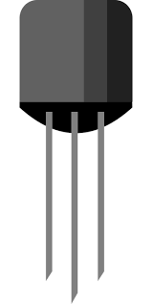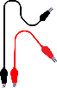

SWITCH

BATTERY/CELL

**DANGER! HIGH VOLTAGE!**

Electricity is everywhere so always be safe. Be careful of mains switches, open sockets and any signs to do with electricity. The human body is 80% water so it conducts electricity. If someone has had a shock always turn the electricity off first, then call for help!

WIRES