Welcome Back
It has been an excellent start to the year, and we are so pleased that everybody, including our new Reception children have settled in so well. Our Year 6 children have already become wonderful and supportive buddies to them.
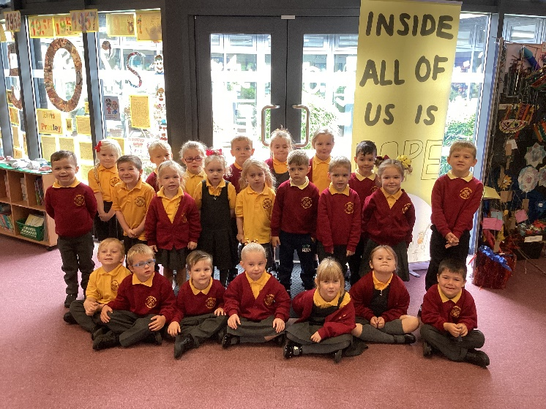
Dates for your diary
New Starters Open Evening Tue 4th October
4-5.30pm
Harvest Festival Wed 5th October 1.30pm
Chester Zoo trip Y1-6 Thurs 6th October
Behaviour workshop Wed 13th October
KS1 Parents’ Evening Wed 19th October
KS2 Parents’ Evening Thurs 20th October

Appointments for Parents’ Evening will be sent nearer the time. We are looking forward to being able to get back to face to face appointments this year.

Reminders:
Trainers should only be worn on PE days
Earrings should not be worn for school. If they have to be worn they must be small, plain studs only and need covering for PE.
Please remind children that they should not be on equipment at the start or end of the school day. Our insurance does not cover this, and we cannot be held responsible for any accidents that occur at this time.
Attendance and punctuality
Our whole school attendance: 94.65%
Reception | 95.5%
Year 1 | 95.2%
Year 2 | 94.0%
Year 3 | 94.6%
Year 4 | 94.5%
Year 5 | 94.0%
Year 6 | 94.9%

Well done to Reception! Best attendance in September.
Every single day a child is absent from school equates to a day of lost learning. Children are busy from the minute that they come into school. If they are late they are losing valuable time. Please try and be on time!
Help and support
Earlier in the term I sent out a letter about applying for pupil premium, even if your child got free school meals in KS1. This ensures that we receive extra money in school which can be spent on supporting all our children. The link is here:
https://www3.halton.gov.uk/Pages/EducationandFamilies/Schools/FreeSchoolMeals
However, I also wanted to make you aware of a scheme which you can use if you use breakfast or after school clubs. This provides up to £2000 a year to help with the cost of childcare. I hope this will be of help to some of you.
https://www.gov.uk/tax-free-childcare
Seesaw and Tapestry
All of the information that your child needs for home will be available on the class Seesaw (Tapestry for Reception). We are trying to reduce the amount of paper that we use so all letters should be available on there, rather than requesting a paper copy.
Homework is also set on this site so please ensure you keep up to date with what your child should be doing that week.
Reading
Reading is the most important thing that you can do with your child to help them make progress. Please make sure that you are reading with them daily. However old your child is, they love hearing you read to them too! Children learn between 4 and 12 thousand new words a year through reading. Read some more interesting facts here…
https://www.weareteachers.com/reading-facts/
Twitter
We have a new Twitter page at
All Saints Upton@SaintsUpton
Please follow us if you use Twitter! Your class teacher will also let you know what their own Twitter page is, and I will include all of these in the next newsletter.
Christian Values
You may have heard your children talk about winning a Values award each week. We have a Christian value for each half term and two children in the class win the award each week based on that value. We are also looking forward to having a very special celebration service at the end of each half term where one child from each class will get an extra special mention and award!
Our values for the year are Love, Hope, Perseverance, Forgiveness, Thankfulness and Trust. You can read more about this on our website.
Mrs. Davies

